GitOps (Can be used for application delivery and Infrastructure delivery)

No versioning in Kubernetes, if any changes happen to the node we can’t predict who has made the change.

Setting tracking for deployment - is the purpose of GitOps.

Nodes will be put in git hub -> Pull and make the changes, another DevOps engineer will check and approve -> GitOps controller reads the change and deploys the same.

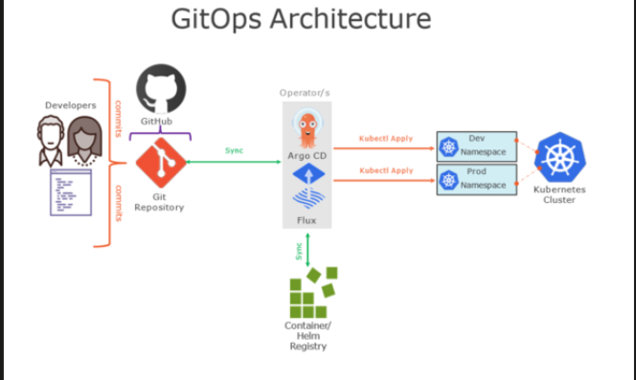

Principles of GitOps

- Declarative -> System managed by GiOps must have its desired state expressed declaratively (What you see is what you have)
- Versioned and Immutable
- Pulled Automatically
- Continuously Reconciling - First change in github then it will be reflected in the nodes that are controlled by GitOps.
  - If there is any difference between Github and Kubernetes cluster side it overrides the Kubernetes cluster side as it blindly believes that GitHub is correct (Single side of truth)

Popular GitOps controllers like Argo CD and Flux CD supports only Kubernetes for now.

GitOps Tools:

ARGO CD
FLUX CD
JenkinsS
Spinnaker

Argo CD - GitOps for CD

- Open source
- Maintains the state between Version control system and K8s cluster
- Keeps in sync

Architecture:

Git -> Repo server (Connect to git and get the state) (Microservices)
Kubernetes -> Application Controllers (Connect to k8s to the state)
To Connect to Argo CD (UI/CLI) -> API Server -> Dex (Used for authentication)
Redis -> For Caching Information (Information on what has happened till now)

Installation:

- minikube status
- kubectl create namespace argocd
kubectl apply -n argocd --server-side --force-conflicts -f https://raw.githubusercontent.com/argoproj/argo-cd/stable/manifests/install.yaml

Check for pods:
kubectl get pods -n argocd -w

Check services:
kubectl get svc -n argocd

Edit the service so that we can access it in browser:
kubectl edit svc argocd-server -n argocd
- Change the type : NodePort
- minikube service list -n argocd
- minikube service argocd-server -n argocd
  - Take any of the url

Login to Argocd without any identity provider - UI
- kubectl get secret -n argocd
- kubectl edit secret argocd-initial-admin-secret -n argocd
- TO get the password:
  - echo secret | base64 –decode
- User name: admin

To deploy:
kubectl get deploy

Demo:

Multi cluster deployment with GitOps

Install AWS:
sudo apt update
sudo apt install awscli -y

Config AWS:
aws configure

Enter the access key and secret access
E.g: AWS Access Key ID: AKIA...
AWS Secret Access Key: xxxxx...
Default region name: ap-south-1
Default output format: json

To verify: aws sts get-caller-identity

Hub cluster:
eksctl create cluster --name hub-cluster --region ap-south-1

2 Spoke cluster:
eksctl create cluster --name spoke-cluster-1 --region ap-south-1
eksctl create cluster --name spoke-cluster-2 --region ap-south-1

Now move the context to HUB cluster:
kubectl config get-contexts
kubectl config get-contexts | grep ap-south-1

Take the hub-cluster:
kubectl config use-context <hib-cluster>

Config the cluster:
kubectl config current–context

Now install ArgoCD: Follow the above steps

Get all the pods:
kubectl get pods -n argocd

